Day: 18 (05-11-2026) | Load data from snowflake and visualize data using Power BI | Documented By:
Task – 2 | Load data from snowflake and visualize data using Power BI | Sujit T K

- Create a new database in snowflake
CREATE DATABASE AJI_DB_V3;
SHOW DATABASES LIKE 'AJI_DB_V3';
USE DATABASE AJI_DB_V3;
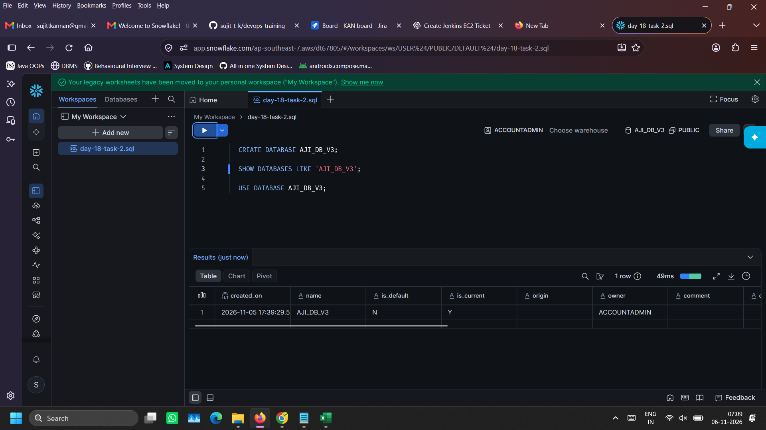
- Create a new schema
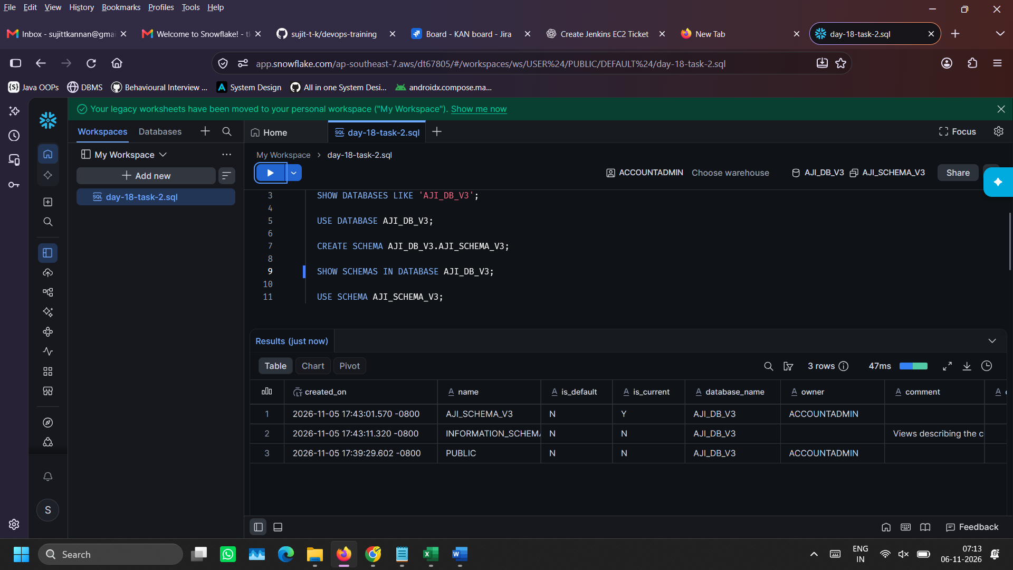
CREATE SCHEMA AJI_DB_V3.AJI_SCHEMA_V3;
SHOW SCHEMAS IN DATABASE AJI_DB_V3;
USE SCHEMA AJI_SCHEMA_V3;

- Create a table structure to hold data
CREATE TABLE ORDERS (
ORDER_ID VARCHAR(16),
ORDER_TIMESTAMP TIMESTAMP_NTZ,
CUSTOMER_NAME VARCHAR(64),
CITY VARCHAR(32),
QUANTITY INT,
PRODUCT_NAME VARCHAR(64),
PRODUCT_CATEGORY VARCHAR(32),
UNIT_PRICE NUMBER(10,2),
REVENUE NUMBER(12,2)
);

SHOW TABLES IN SCHEMA AJI_DB_V3.AJI_SCHEMA_V3;
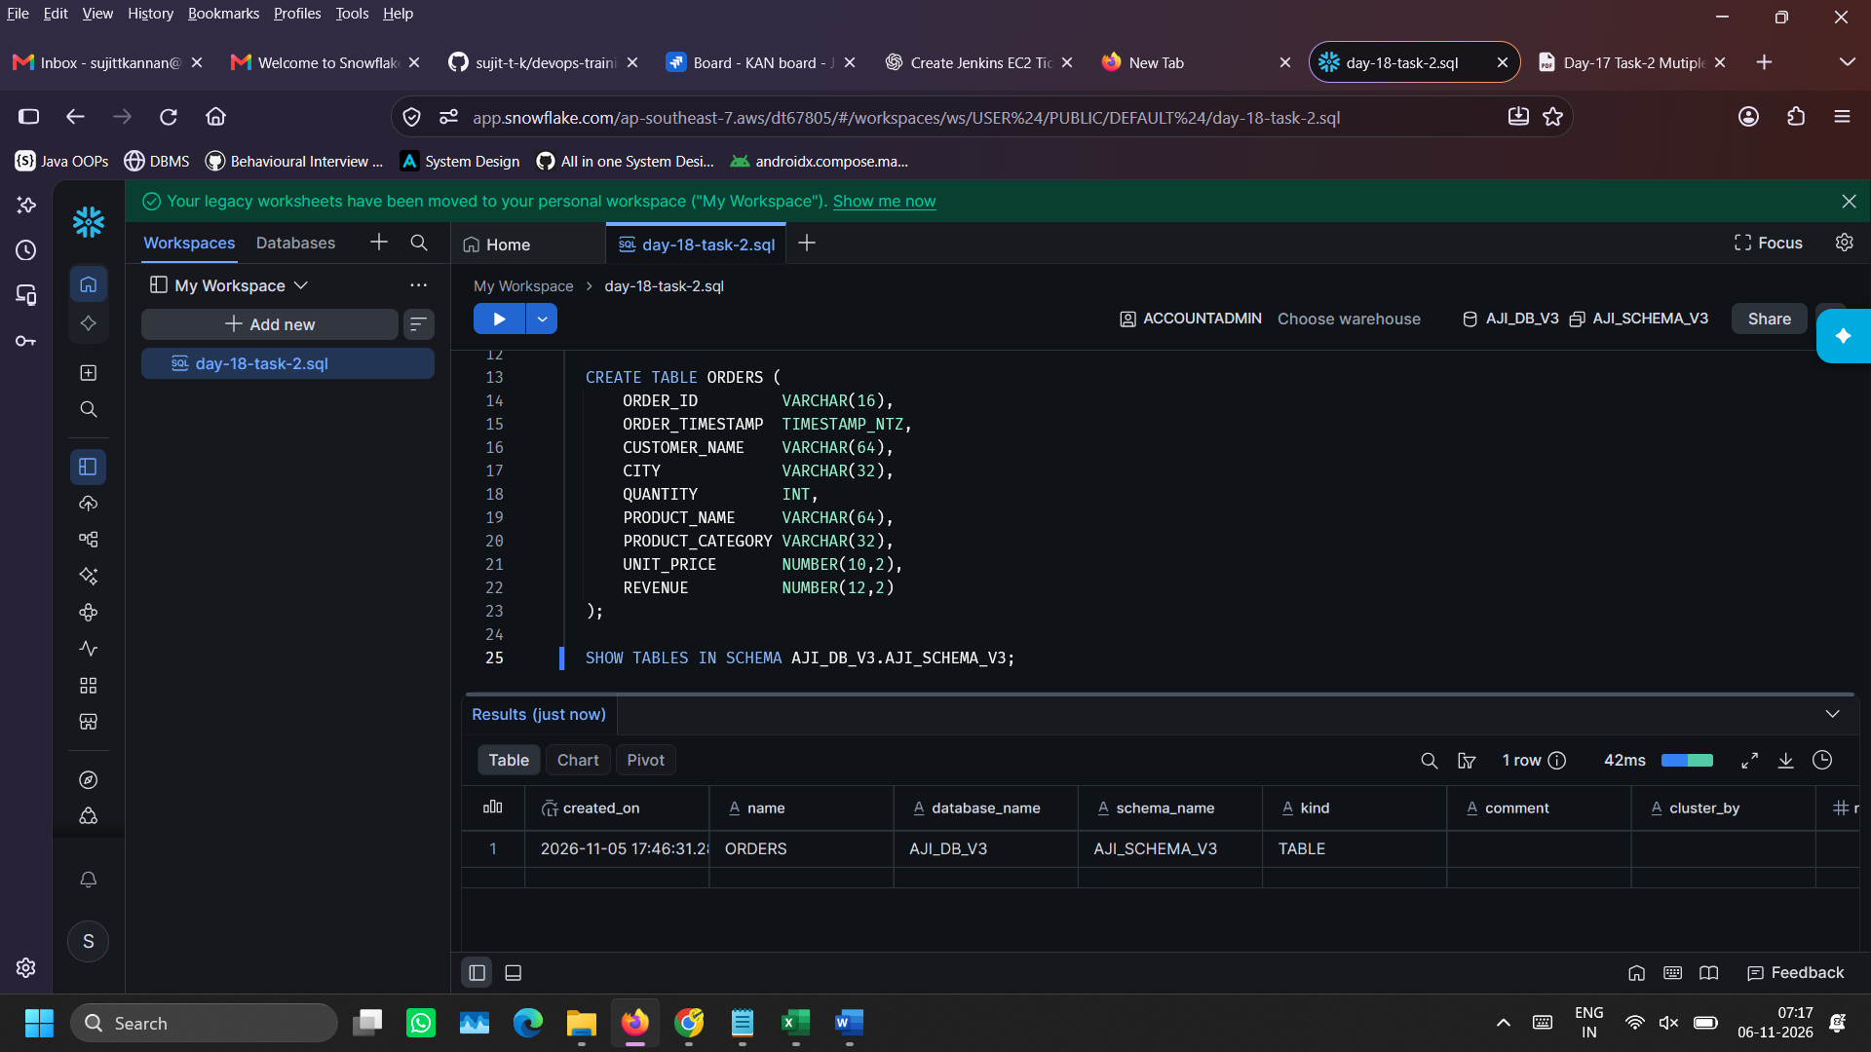

- Create warehouse, file format and stage to upload .csv file into snowflake environment

CREATE WAREHOUSE AJI_WH_V3;
USE WAREHOUSE AJI_WH_V3;

CREATE FILE FORMAT AJI_FILE_FORMAT_V3
TYPE = CSV
SKIP_HEADER = 1
FIELD_OPTIONALLY_ENCLOSED_BY = '"'
EMPTY_FIELD_AS_NULL = TRUE;

CREATE OR REPLACE STAGE AJI_STAGE_V3
FILE_FORMAT = AJI_FILE_FORMAT_V3;

SHOW STAGES IN SCHEMA AJI_DB_V3.AJI_SCHEMA_V3;
SHOW FILE FORMATS IN AJI_DB_V3.AJI_SCHEMA_V3;
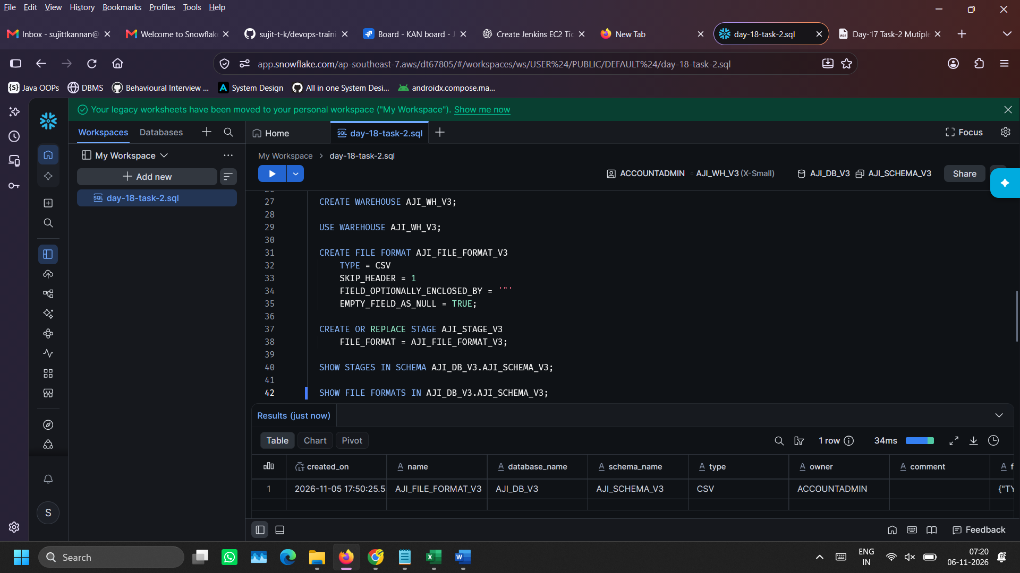

- Upload .csv file into the stage created going to Catalog > Explorer.

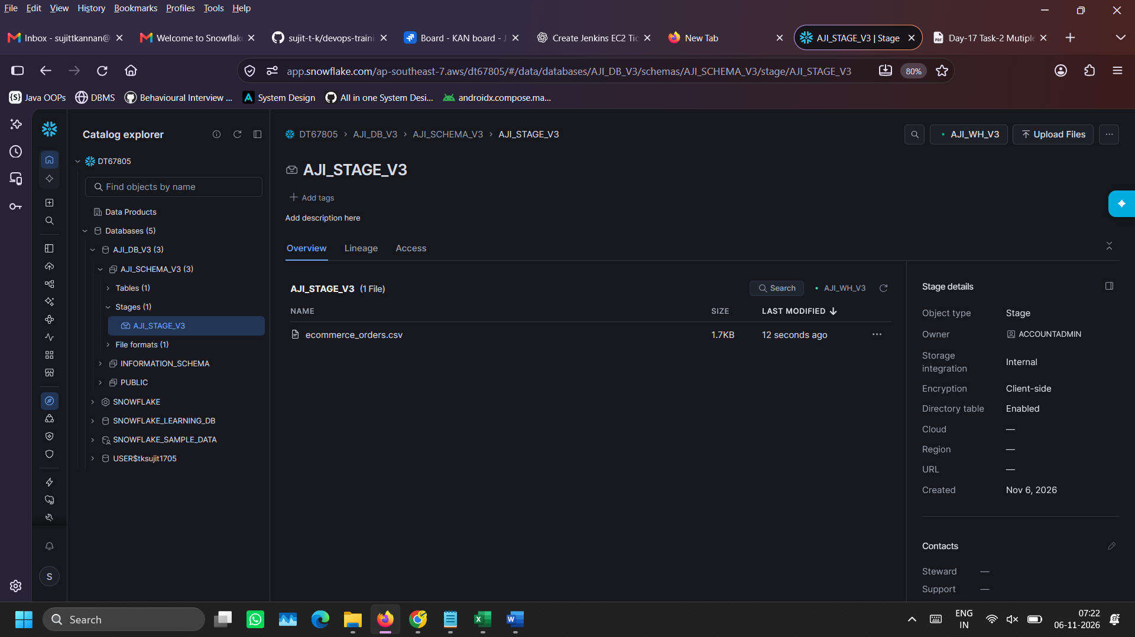

- View the staged data using SQL for verification

LIST @AJI_STAGE_V3;
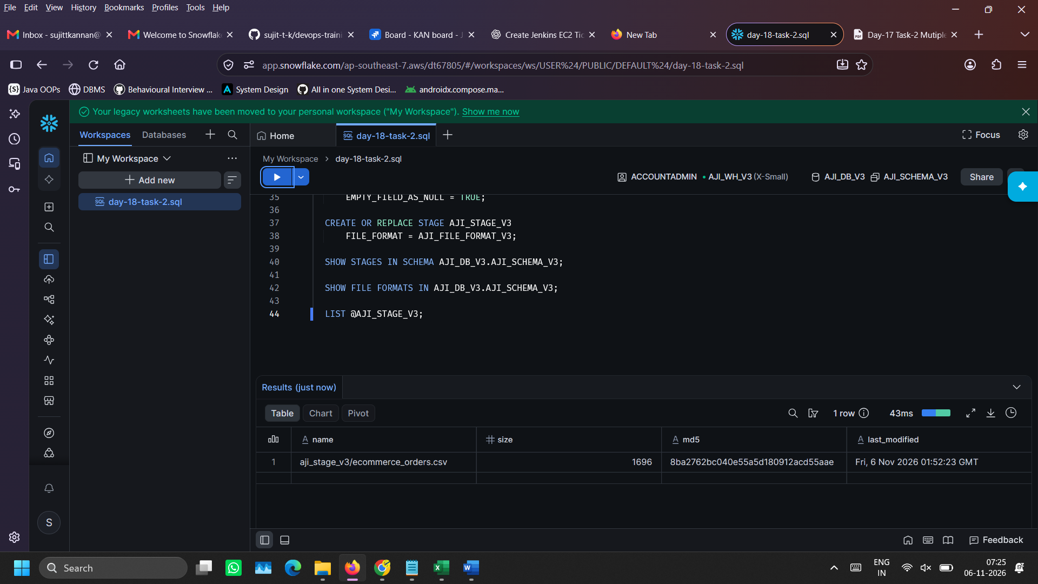

- Load data from .csv into snowflake table using COPY INTO command and verify data load using DESCRIBE TABLE command

COPY INTO ORDERS
FROM @AJI_STAGE_V3
FILES = ('ecommerce_orders.csv')
FILE_FORMAT = (FORMAT_NAME = 'AJI_FILE_FORMAT_V3')
ON_ERROR = 'ABORT_STATEMENT';

DESCRIBE TABLE ORDERS;
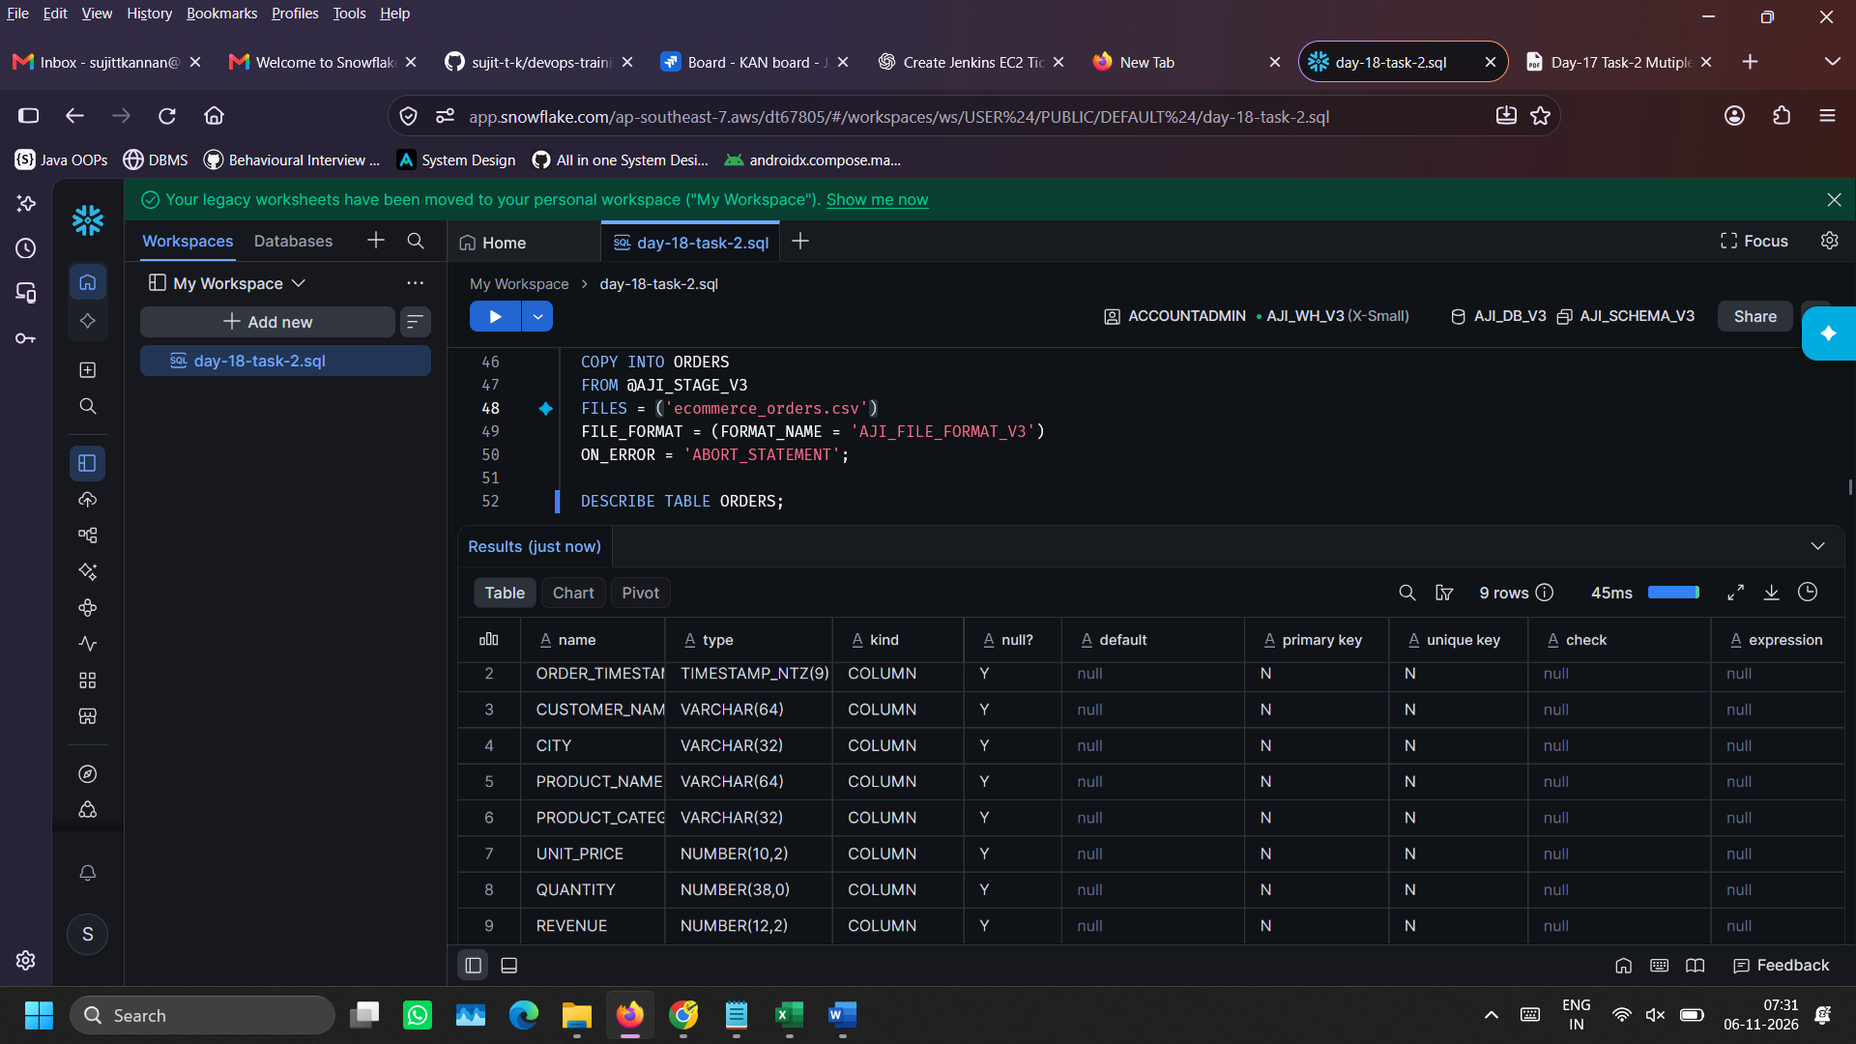

- Open PowerBI desktop and load data by selecting ‘Get data from other sources’
- Search for ‘Snowflake’ and then provide snowflake server URL and warehouse name.
- Authenticate with snowflake credentials if required.
- Then on navigator panel on right left side, locate the Orders table and press on ‘Transform Data’

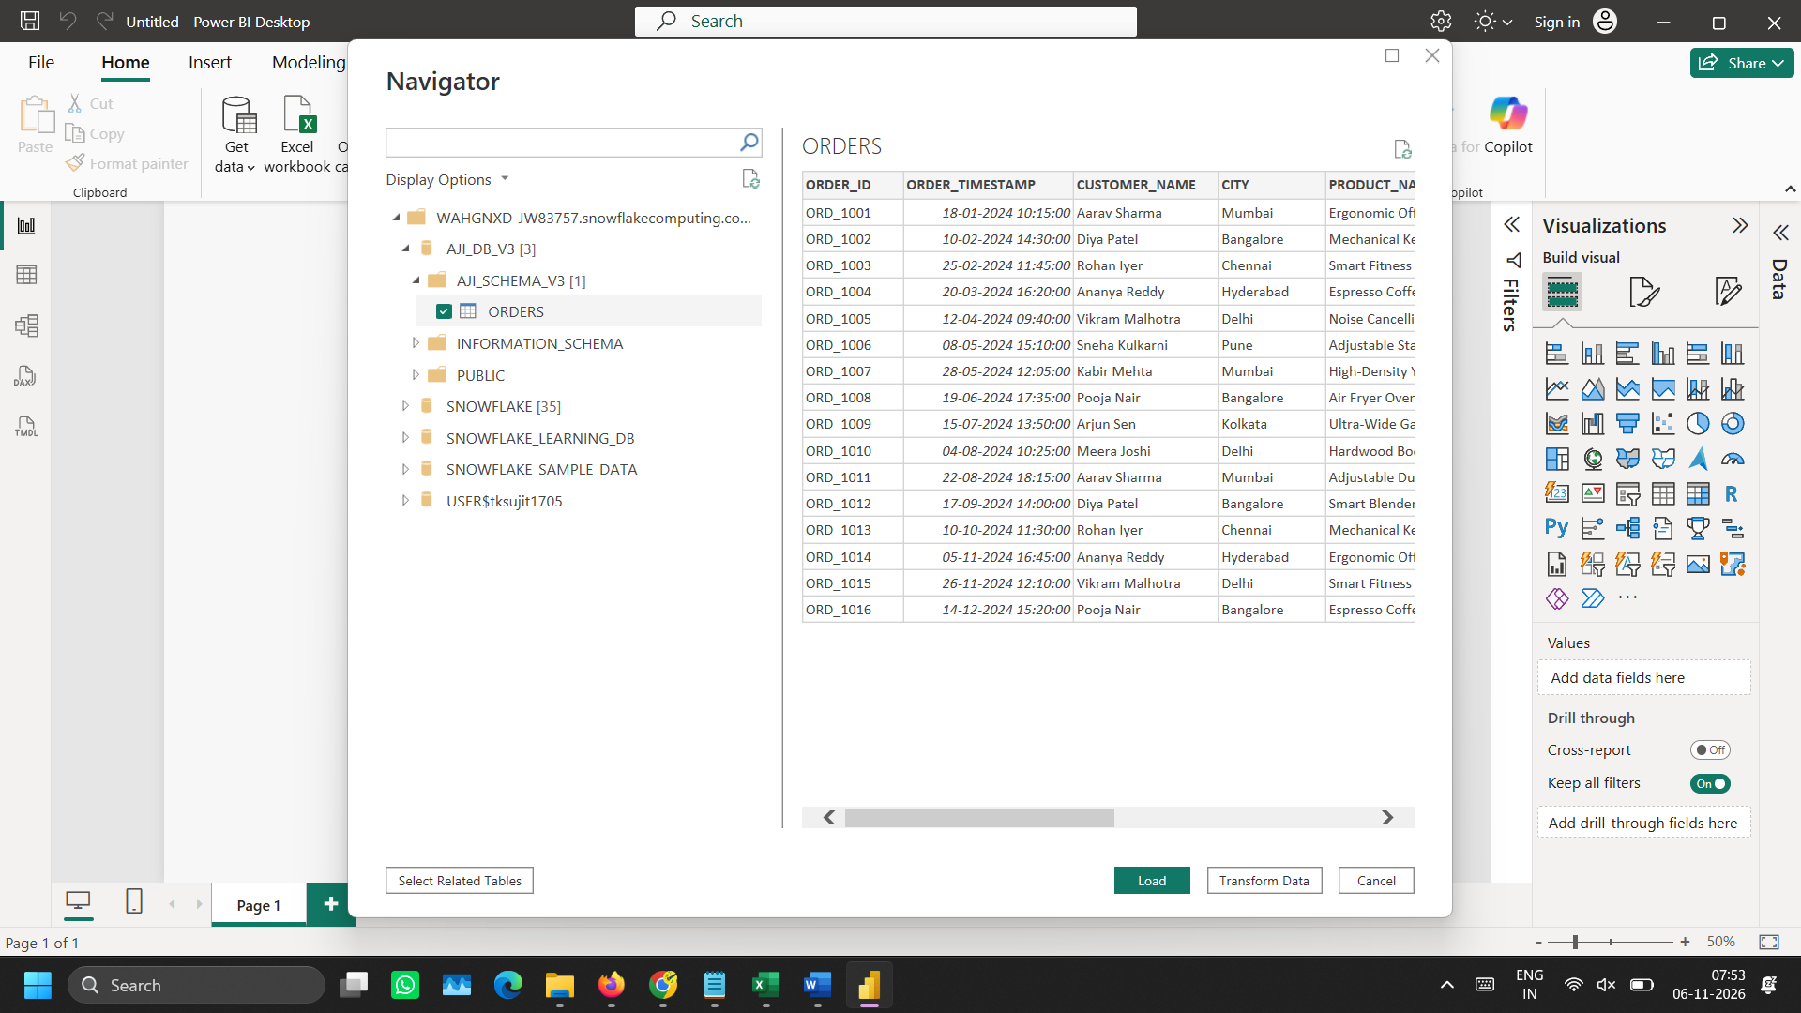

- Choose ‘Import’ as data source mode.
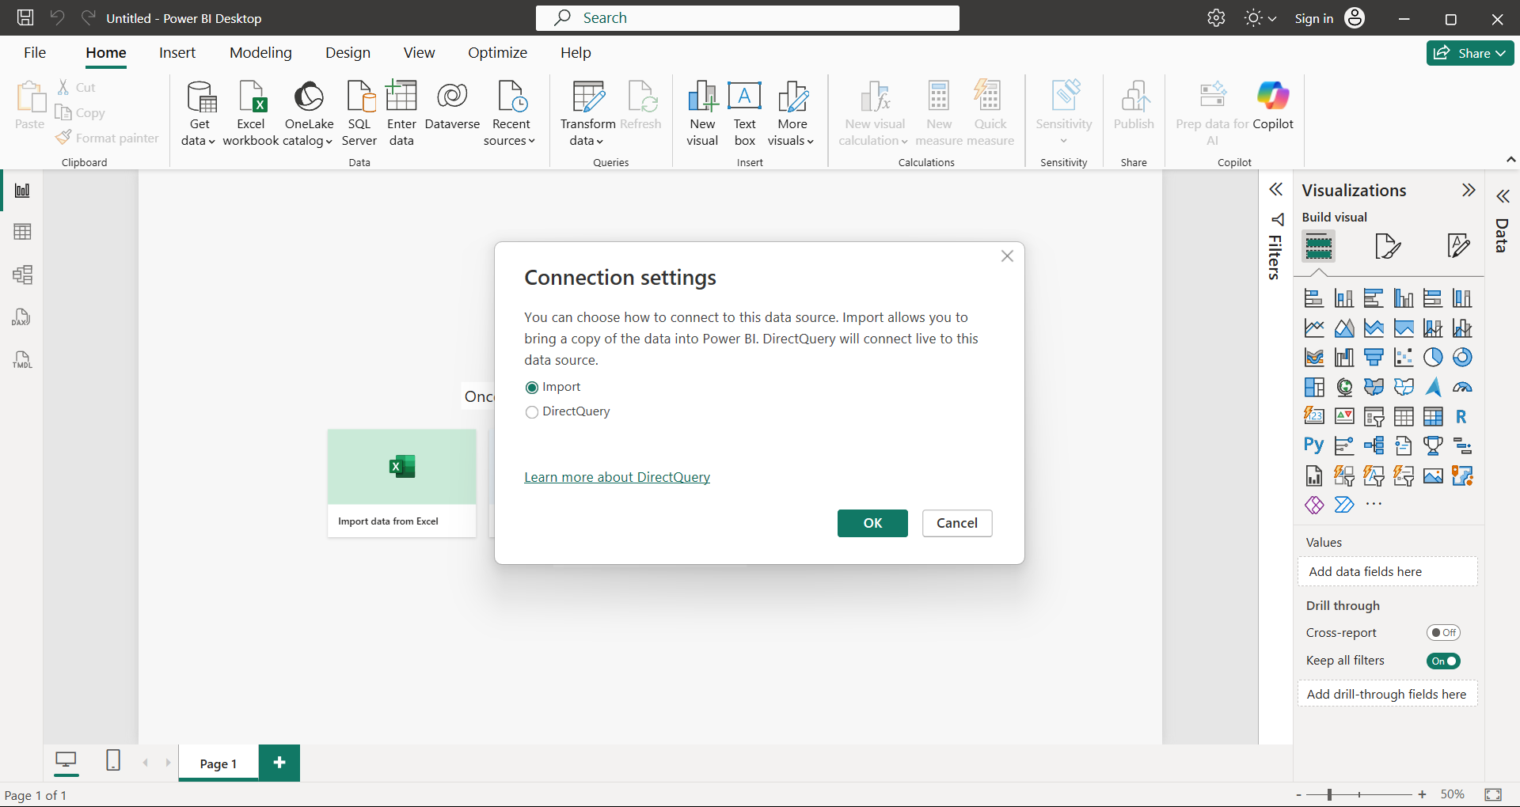

- Click on ‘Close and Apply’ button on Home tab after performing transformation.
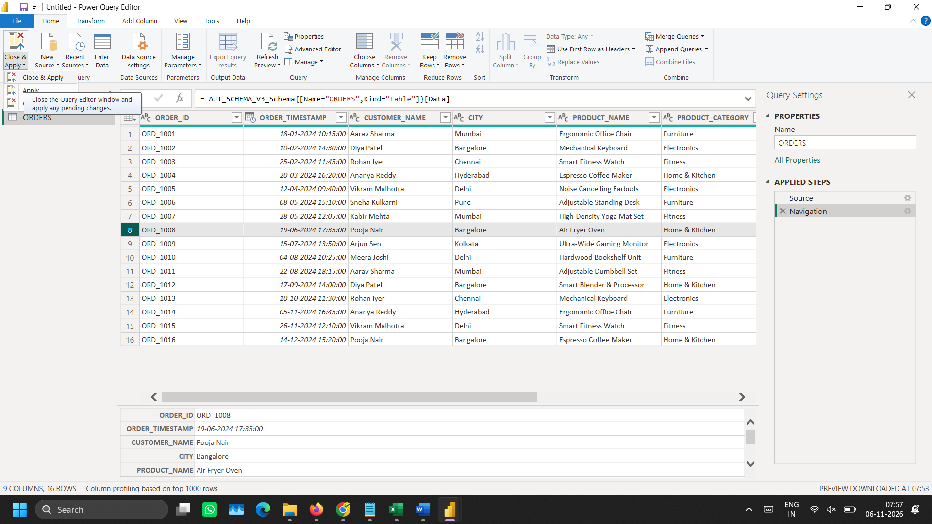

- Use various visualization charts and cards in ‘view reports’ area to create a dashboard
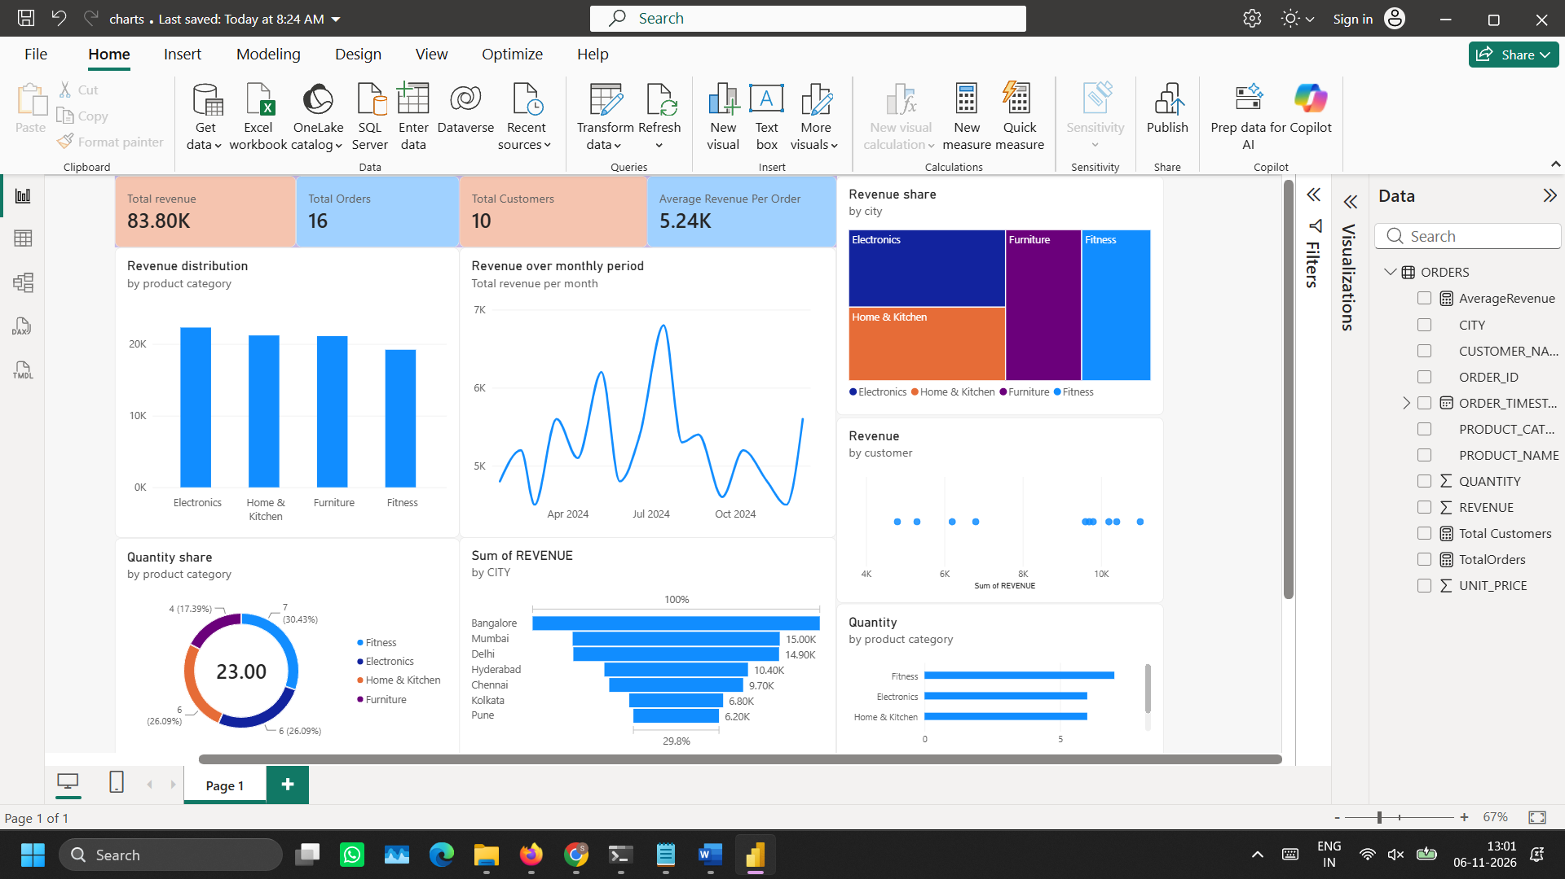

- Click on any category to filter and view information related to that selected category
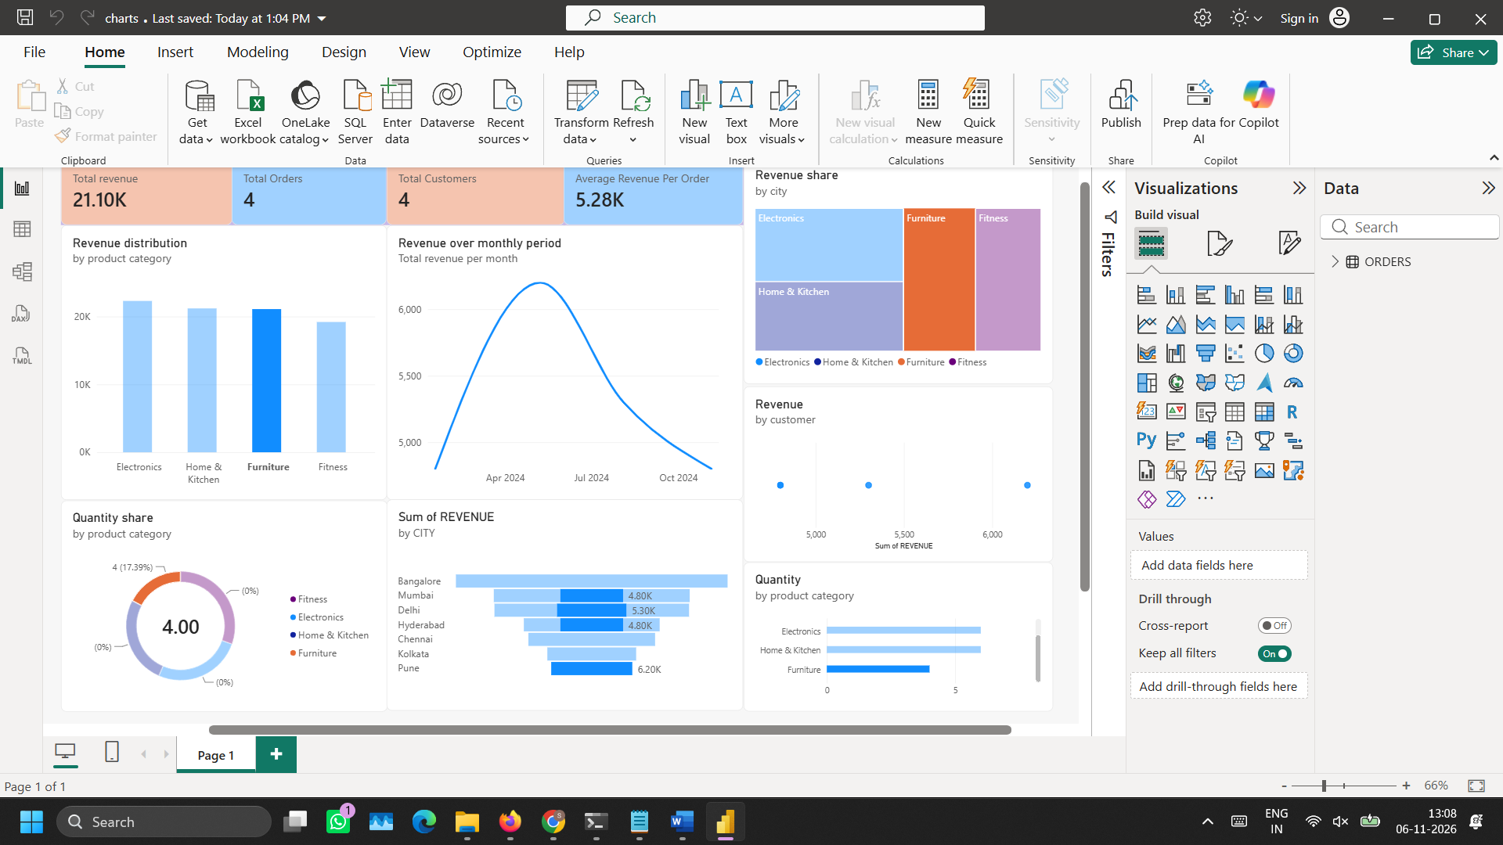

- Delete database and warehouse in Snowflake

DROP DATABASE AJI_DB_V3;

DROP WAREHOUSE AJI_WH_V3;



